LAPORAN PRAKTIKUM PHP EXERCISES W3SCHOOL

Disusun Oleh :

Nama : Aulia Claudia Rahma

Prodi / Kelas :Sistem Informasi Kelautan / Kelas B

NIM : 2008030

**UNIVERSITAS PENDIDIKAN INDONESIA KAMPUS DAERAH SERANG**

**SISTEM INFORMASI KELAUTAN**

**TAHUN 2021**

**DAFTAR ISI**

PHP TUTORIAL 4

**1.** **PHP Syntax** 4

1.1 Exercise 1 4

1.2 Exercise 2 5

1.3 Exercise 3 5

1.4 Exercise 4 6

1.5 Exercise 5 6

**2.** **PHP Variabels** 7

2.1 Exercise 1 7

2.2 Exercise 2 7

**3.** **PHP String** 8

3.1 Exercise 1 8

3.2 Exercise 2 8

3.3 Exercise 3 9

**4.** **PHP Operators** 9

4.1 Exercise 1 9

4.2 Exercise 2 10

4.3 Exercise 3 10

4.4 Exercise 4 11

**5.** **PHP IF Else** 11

5.1 Exercise 1 11

5.2 Exercise 2 12

5.3 Exercise 3 12

5.4 Exercise 4 13

**6.** **PHP Switch** 14

6.1 Exercise 1 14

6.2 Exercise 2 14

**7.** **PHP Loop** 15

7.1 Exercise 1 15

**8.** **PHP Functions** 17

8.1 Exercise 1 17

8.2 Exercise 2 18

8.3 Exercise 3 18

1.1 Exercise 4 19

**9.** **PHP Arrays** 19

9.1 Exercise 1 19

9.2 Exercise 2 20

9.3 Exercise 3 20

9.4 Exercise 4 20

9.5 Exercise 5 21

9.6 Exercise 6 21

9.7 Exercise 7 22

9.8 Exercise 8 22

**10.** **PHP Form** 23

10.1 Exercise 1 23

10.2 Exercise 2 24

**11.** **PHP Dates** 24

11.1 Exercise 1 24

11.2 Exercise 2 25

11.3 Exercise 3 25

**12.** **PHP Advanced** 25

12.1 Exercise 1 25

12.2 Exercise 2 26

12.3 Exercise 3 26

12.4 Exercise 4 27

12.5 Exercise 5 27

12.6 Exercise 6 28

**PHP EXERCISES W3SCHOOL**

# PHP TUTORIAL

## **PHP Syntax**

### Exercise 1

Insert the missing part of the code below to output "Hello World"

echo “Hello World”;

### Exercise 2

Write the correct opening tag and close tag for PHP scripts

<? php

echo “This is PHP”; ?>

### Exercise 3

Single-line comments in PHP can be written using two different prefixes, write one of them.

// This is single line comment

### Exercise 4

Insert the correct characters to write a multi-line comment.

/* This is a

multi-line

commnent */

### Exercise 5

Statements in PHP have to end with a special character, which one?

echo “Hello World”;

## **PHP Variabels**

### Exercise 1

Create a variable named txt and assign the value "Hello".

$txt=”Hello”;

### Exercise 2

Create one variable named x, and one variable named y, then use the echo statement to output the sum of x and y.

$x = 5;

$y = 7;

echo $x+$y;

## **PHP String**

### Exercise 1

Get the length of the string "Hello World!".

echo strlen(“Hello World”);

### Exercise 2

Reverse the string "Hello World!".

echo strrev(“Hello World”);

### Exercise 3

Replace the word "World" with the word "Dolly".

$oldtxt = “Hello World”

$newtxt = str_replace(“World”,”Dolly”,$oldtxt)

## **PHP Operators**

### Exercise 1

Multiply 10 with 5, and output the result.

echo 10*5;

### Exercise 2

Divide 10 by 2, and output the result.

echo 10/2;

### Exercise 3

Use the correct comparison operator to check if $a is equal to $b.

var_dump($a==$b);

### Exercise 4

Use the correct comparison operator to check if $a is NOT equal to $b.

var_dump($a!=$b);

## **PHP IF Else**

### Exercise 1

Output "Hello World" if $a is greater than $b.

$a=50;

$b=10;

if ($a > $b){

echo “Hello World”; }

### Exercise 2

Output "Hello World" if $a is NOT equal to $b.

$a=50;

$b=10;

if ($a != $b){

echo “Hello World”; }

### Exercise 3

Output "Yes" if $a is equal to $b, otherwise output "No".

$a=50;

$b=10;

if ($a == $b){

echo “Yes”;}

else {

echo “No”;}

### Exercise 4

Output "1" if $a is equal to $b, print "2" if $a is greater than $b, otherwise output "3".

$a = 50;

$b = 10;

if ($a == $b) {

echo "1";

} elseif ($a > $b) {

echo "2";

} else {

echo "3";

}

## **PHP Switch**

### Exercise 1

Create a switch statement that will output "Hello" if $color is "red", and "welcome" if $color is "green".

switch ($color){

case “red”:

echo “Hello”;

break;

case “green”:

echo “Welcome”;

break;}

### Exercise 2

Add a section that will output "Neither" if $color is neither "red" nor "green".

switch ($color){

case “red”:

echo “Hello”;

break;

case “green”:

echo “Welcome”;

break;

default : echo “Neither”;}

## **PHP Loop**

### Exercise 1

Output $i as long as $i is less than 6.

$i=1;

while($i<6){

echo $i;

$i++;}

* 1. Exercise 2

Output $i as long as $i is less than 6.

$i=1;

do{

echo $i;

$i++;}

while ($i<6);

* 1. Exercise 3

Create a loop that runs from 0 to 9.

for ($i=0; $i<10; $i++){

echo $i;}

* 1. Exercise 4

Create a loop that runs from 0 to 9.

$color = array(“red”,”green”,”blue”,”yellow”);

foreach ($color as $x){

echo $x;}

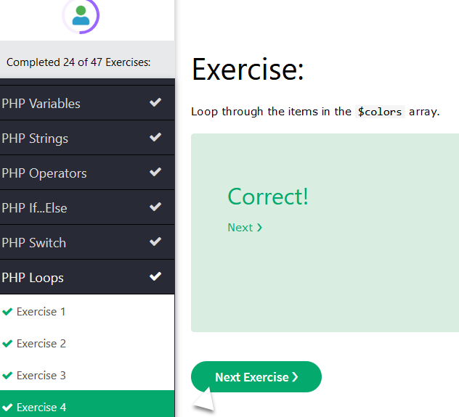

## **PHP Functions**

### Exercise 1

Create a function named myFunction.

function myFunction(){

echo “Hello World”;}

### Exercise 2

Call (execute) a function named myFunction.

function myFunction(){

echo “Hello World”;}

myFunction();

### Exercise 3

Inside a function with two parameters, print the first parameter.

function myFunction($fname, $lname){

echo $fname;}

### Exercise 4

Let the function return the second value.

function myFunction($fname, $lname){

return.$lname;}

## **PHP Arrays**

### Exercise 1

Use the correct function to output the number of items in an array.

$fruits = array("Apple", "Banana", "Orange");

echo count($fruit);

### Exercise 2

Output the second item in the $fruits array.

$fruits = array("Apple", "Banana", "Orange");

echo $fruit[1];

### Exercise 3

Create an associative array containing the age of Peter, Ben and Joe.

$age = array("Peter"=>"35", "Ben"=>"37", "Joe"=>"43");

### Exercise 4

Here you see an associative array. Output "age" of Ben.

$age = array("Peter"=>"35", "Ben"=>"37", "Joe"=>"43");

echo “Ben is ”.$age[‘Ben’].”years old”;

### Exercise 5

Loop through an associative array and output the key and the value.

foreach($age as $x => $y)

echo “Key”.$x.”, Value=”.$y;}

### Exercise 6

Use the correct array method to sort the $colors array alphabetically.

$color = array(“red”,”green”,”blue”,”yellow”);

sort($colors);

### Exercise 7

Use the correct array method to sort the $colors array descending alphabetically.

$color = array(“red”,”green”,”blue”,”yellow”);

rsort($colors);

### Exercise 8

Use the correct array method to sort the $age array according to the values.

$age = array("Peter"=>"35", "Ben"=>"37", "Joe"=>"43");

asort($age);

## **PHP Form**

### Exercise 1

If the form in the white section below gets submitted, how can you, in welcome.php, output the value from the "first name" field.

<form action="welcome.php" method="get">

First name: <input type="text" name="fname">

</form>

<html>

<body>

Welcome <?php echo $_GET[“fname”] ; ?>

</body>

</html>

### Exercise 2

If the form in the white section below gets submitted, how can you, in welcome.php, output the value from the "first name" field?.

Hint: The http method is not the same as in Exercise 1.

<form action="welcome.php" method="get">

First name: <input type="text" name="fname">

</form>

<html>

<body>

Welcome <?php echo $_POST[“fname”] ; ?>

</body>

</html>

## **PHP Dates**

### Exercise 1

Use the correct date function to output the weekday of today (monday, tuesday etc.).

echo date(“1”);

### Exercise 2

Use the correct format parameter to output a date like this: 2021.10.12.

echo date(“Y.m.d”);

### Exercise 3

Use the correct format parameter to output the time like this: 22:22:19 (with hour as a 24-hour format).

echo date(“H:i:s”);

## **PHP Advanced**

### Exercise 1

Write a correct syntax to include a file named "footer.php".

<?php include ‘footer.php’;?>

### Exercise 2

Assume we have a file named "webdict.txt", write the correct syntax to open and read the file content.

echo readfile(“webdict.txt”);

### Exercise 3

Open a file, and write the correct syntax to output one character at the time, until end-of-file.

$myfile = fopen("webdict.txt", "r");

while(!feof($myfile)) {

echo fgetc($myfile);}

### Exercise 4

Create a cookie named "username".

setcookie("username", "John", time() + (86400 * 30), "/");

### Exercise 5

Create a session variable named "favcolor".

session_start();

$_SESSION[“favcolor”]=”green”;

### Exercise 6

Output the value of the session variable "favcolor".

echo $_SESSION["favcolor"];

